Assignment 3: Lighting and Texture Mapping

The structure of project：

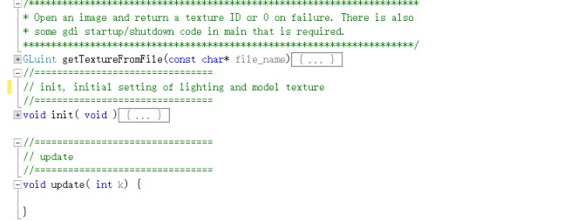

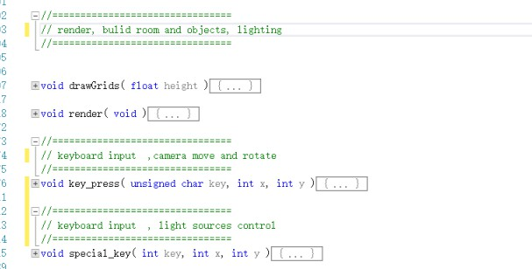

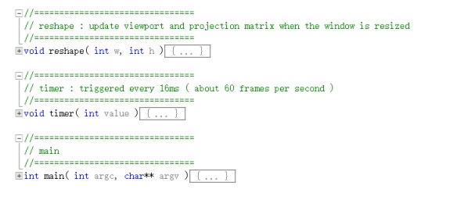

This is the structure of the main class SimpleGLUT, just as notes said that I use the getTextureFromFile function to load textures. And using init function to set the lights attributes, textures and load models. And main works are done in the render function, it draws two light sources (spot and point) and enable lighting, also draws model with new draw method (as following) with back face removal then build floor, walls and ceiling with texture by using texture coordinates and back face removal.

In model.h , I update the draw method.

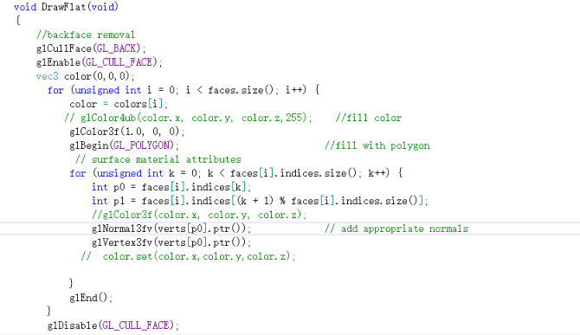

P.S KEYBOARD DESCRIPTION:

F1 open light source 2

F2 close light source 2

Up, Down move up or down light source 1

Right, Left move right or left light source 1

W, A, S, D move camera

R, F raise and down camera

Q, E rotate camera

<https://youtu.be/uSKqIkQhsCg>